AI-Augmented Backend Development Project : AI FAQ Assistant API

TITLE : AI FAQ Assistant API

Project Description

In a Single Paragraph
AI FAQ Assistant API is an AI-Augmented backend Web Application developed using the (MongoDB, Express.js,Node.js) integrated with Artificial Intelligence capabilities such as Large Language Models (LLMs), Semantic Search, Vector Search, and Intelligent Recommendations. The system enables users to interact with data through natural language, receive AI-generated insights, perform semantic searches, upload and analyze documents, and automate decision-making processes. By combining traditional backend development with modern AI technologies, the platform delivers an intelligent, scalable, and user-friendly experience that improves productivity, accessibility, and operational efficiency.

Scenario
Many organizations receive a large number of frequently asked questions from users regarding products, services, procedures, policies, and general information. In traditional systems, users often have to search through static FAQ pages, documents, or manually contact support staff to find answers. This process can be time-consuming, especially when the required information is difficult to locate or the FAQ database contains a large amount of content. Manual handling of repeated questions also increases the workload for support teams and may result in delayed responses.
Identify the Problem
Explain a real-world problem faced by users or organizations in the selected domain. Mention the limitations of traditional systems or manual processes.
- Traditional FAQ systems mainly depend on keyword-based searches and fixed answers. They may not understand questions when users use different words, phrases, or natural language. As the FAQ database grows, finding the correct information becomes more difficult and manual support teams may have to handle repeated questions. Artificial Intelligence can improve this process by understanding the meaning of user queries, identifying relevant information, and generating suitable responses automatically.

  - Describe the Proposed Solution
  - The AI FAQ Assistant API provides an AI-powered backend for answering user questions from an FAQ knowledge base. It can use the following AI capabilities:
  - AI Chatbot
  - Content Generation
  - Question Answering
  - Semantic Search
  - Vector Search
  - Intelligent Recommendations
  - Document Analysis
  - AI-powered Insights

Structure :
Paragraph 1 – Problem:
What problem exists in the selected domain? What difficulties do users currently face?
Paragraph 2 – AI Solution:
How will your application solve the problem using AI? Which AI features will be included?
Paragraph 3 – Impact:
Who will benefit from the application, and how will it improve the existing process?

System Requirements :
To ensure smooth development, deployment, and usage of the < Project Name > AI-Augmented Backend Application, certain system prerequisites must be met.

1. Software Requirements

Operating System
- Windows 10/11
- macOS
- Linux

Node.js (v18 or above)
Provides a runtime environment for frontend and backend development.

npm (v9 or above)
Package manager used for dependency installation.

Express.js
Backend framework used for API development.

MongoDB Community Server / MongoDB Atlas
NoSQL database used to store:
- User Information
- Chat History
- Documents
- Embeddings
- AI Interactions
- Application Data

MongoDB Atlas Search
Provides full-text search functionality.

MongoDB Atlas Vector Search
Enables semantic search using vector embeddings.

AI Service Provider
- OpenAI API
- Gemini API
- Claude API
- Azure OpenAI (Optional) …etc

LangChain / AI SDK
Used for orchestration of AI workflows.

Browser
- Google Chrome
- Mozilla Firefox

Postman
API Testing

Visual Studio Code
Development Environment

Git & GitHub
Version Control

2. Hardware Requirements

Processor
Intel Core i5 (8th Gen+) / AMD Ryzen 5+

RAM
Minimum 8 GB
Recommended 16 GB

Storage
Minimum 5 GB Free Space

Internet Connection
Required for AI API communication

Display
1366 × 768 or above

Project Architecture

Technical Architecture :

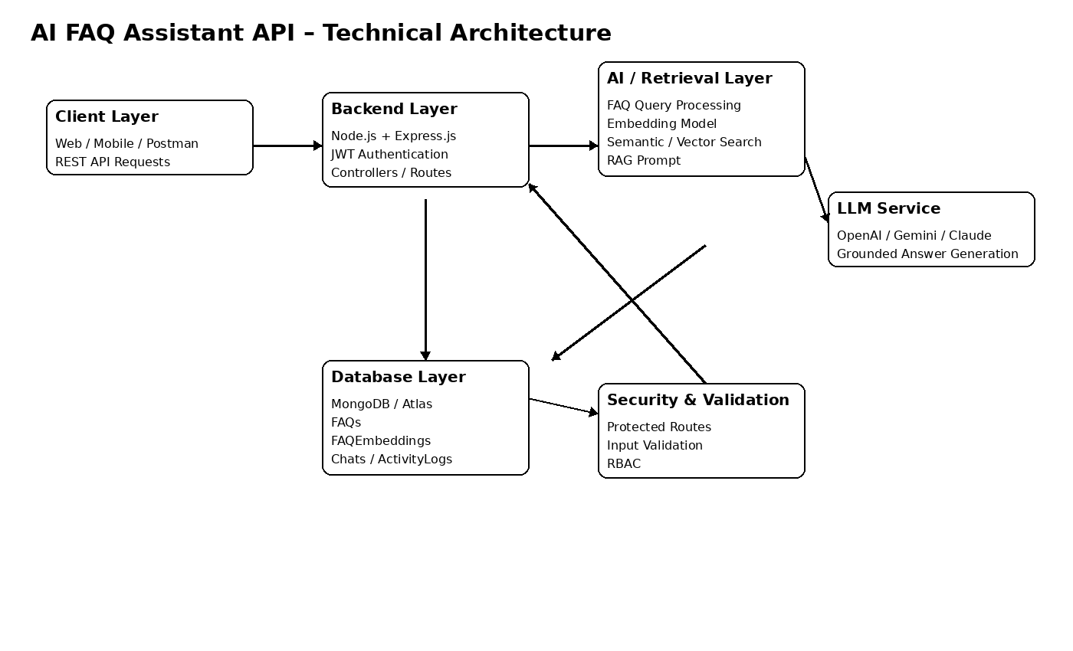Backend Layer
- Node.js
- Express.js
- JWT Authentication
- REST APIs

Database Layer
- MongoDB
- Atlas Search
- Atlas Vector Search

AI Layer
- LLM APIs
- Embedding Models
- RAG Pipeline
- Prompt Engineering

Storage Layer
- MongoDB Collections
- File Upload Storage

Security Layer
- JWT Authentication
- Protected Routes
- Input Validation
- Role-Based Access Control

ER Diagram

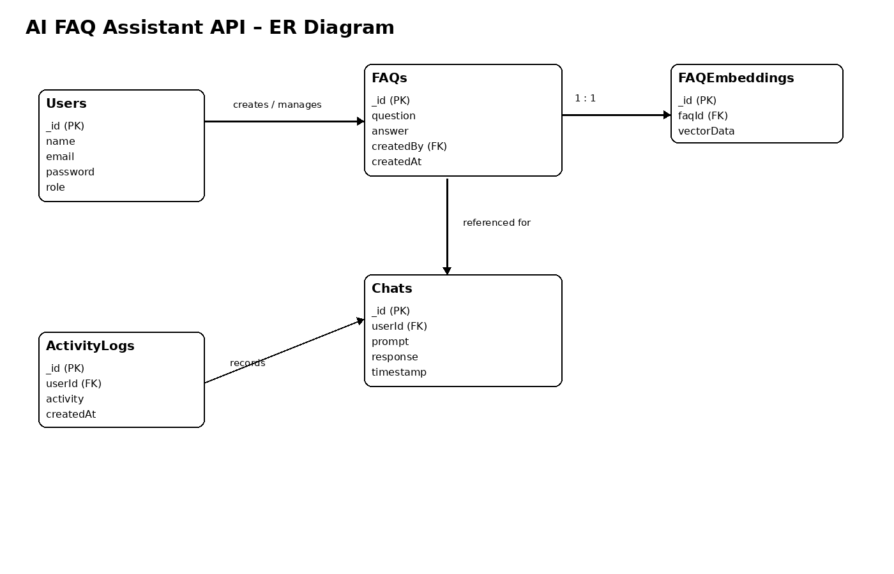Collections

Users
- _id
- name
- email
- password
- role

Documents
- _id
- title
- content
- uploadedBy
- createdAt

Embeddings
- _id
- documentId
- vectorData

Chats
- _id
- userId
- prompt
- response
- timestamp

ActivityLogs
- _id
- userId
- activity
- createdAt

ER Diagram Explanation
Users can upload documents and interact with AI features. Uploaded documents are processed into vector embeddings and stored in MongoDB. Chat interactions and AI responses are logged for future reference and analytics. Activity logs maintain user actions across the system.

Features

Core Backend Features
- User Registration
- User Login
- JWT Authentication
- Protected Routes
- Middleware
- CRUD API
- File Upload
- Role-Based Access Control

AI Features
- AI Chat Assistant
- Semantic Search
- Vector Search
- Document Question Answering
- Text Summarization
- Content Generator
- RAG (Retrieval Augmented Generation)
- Intelligent Insights
- Natural Language Queries

Roles and Responsibilities

Admin
- Manage Users
- Manage Documents
- Monitor AI Usage
- View Analytics
- Configure System

User
- Register/Login
- Upload Documents
- Ask Questions
- Search Content
- View AI Recommendations
- Manage Personal Data

User Flow
- User Registration
- User Login
- JWT Authentication
- Dashboard Access
- Upload Documents
- Generate Embeddings
- Store Vectors in MongoDB
- User Query Submission
- Semantic Search Execution
- AI Response Generation
- Display Results
- Store Chat History

MVC Pattern
The backend follows the MVC (Model-View-Controller) architecture.

Model Layer
Responsible for:
- User Schema
- Chat Schema
- Document Schema
- Embedding Schema
- Activity Schema
Implemented using Mongoose.

Controller Layer
Responsible for:
- Authentication Logic
- AI API Integration
- Document Processing
- Embedding Generation
- Search Operations
- CRUD Operations

View Layer (Routes)
Defines REST API endpoints:

Authentication Routes
- Register
- Login
- Logout

AI Routes
- Chat
- Summarization
- Semantic Search

Document Routes
- Upload
- View
- Delete

User Routes
- Profile
- Dashboard

Advantages of MVC
- Separation of Concerns
- Better Maintainability
- Easy Scalability
- Reusable Components
- Team Collaboration
- Easier Testing

Project Setup and Configuration

Project Structure
Create Project Folder
Inside Project Folder:

Server Folder
Backend Application

Server Setup
mkdir server

cd server

npm init -y
Create:
server.js

models/
controllers/
routes/
middlewares/
config/
services/
utils/


Install Backend Packages
npm install express mongoose cors dotenv bcryptjs jsonwebtoken

npm install openai

npm install multer

npm install nodemon --save-dev


Backend Development
Include:
- Authentication APIs
- JWT Implementation
- AI Service Integration
- Vector Search APIs
- CRUD APIs
- Document Upload APIs
- Chat APIs
AI API consumed, including:
- Purpose:
The primary purpose of the AI API is to process natural-language questions and generate meaningful responses by understanding user questions, generating natural-language answers, providing answers based on retrieved FAQ content, summarizing relevant information, supporting RAG-based responses, and generating related FAQ recommendations.

- Request Structure:

The backend sends a request to the AI API containing the user's question and, when required, relevant FAQ information retrieved through semantic or vector search.

- Response Structure:

The AI API returns a response containing the generated answer. The backend processes this response and sends the appropriate result to the client application.

- Cost Considerations:

AI API usage may be charged according to the provider's pricing model, commonly based on the amount of input and output processed. The project should reduce unnecessary API calls by retrieving relevant FAQ content first, limiting unnecessary context, and using appropriate models for different tasks. API usage and costs should be monitored during development and deployment.

- Security Practices:
The AI API key must be stored securely in environment variables and must not be included directly in source code or exposed to frontend users. Backend authentication and protected API routes should be used to control access to AI functionality. User input should be validated before being sent to the AI service, and sensitive information should not be unnecessarily included in prompts or stored in chat history. Rate limiting and usage monitoring can also be implemented to prevent unauthorized or excessive API usage.

Database Development
Include:
- MongoDB Collections
- Relationships
- Atlas Search Index
- Vector Search Index
- Sample Documents
Provide screenshots and explanation.

Project Execution

Step 1: Backend
cd server

npm install


Step 2: Configure Environment Variables
Create .env
PORT=8000

MONGO_URI=mongodb://localhost:27017/ai_augmented_db

JWT_SECRET=your_secret_key

OPENAI_API_KEY=your_api_key


Step 3: Run Backend
nodemon server.js
Backend URL:
http://localhost:8000


Output with Explanation
- API Testing:
The AI FAQ Assistant API is tested using tools such as Postman to verify that the backend endpoints work correctly. The testing includes user authentication, FAQ creation and retrieval, question submission, AI response generation, search functionality, and error handling. The request and response data are checked to ensure that the API returns the expected results.

- LLM Integration:

The AI FAQ Assistant API integrates a Large Language Model (LLM) to understand natural-language questions and generate meaningful answers. The user's query and relevant FAQ information retrieved from the database are provided to the LLM, which processes the information and returns an appropriate response through the backend API.

- AI Chat Interface:

The AI Chat Interface allows users to communicate with the FAQ Assistant using natural-language questions. Users can enter their questions and receive AI-generated answers based on the available FAQ knowledge base. Chat interactions can also be stored for future reference and analysis.

- Document Upload:

The Document Upload feature allows administrators or authorized users to upload FAQ-related documents to the system. The uploaded content can be processed and stored in the database, and relevant information can be converted into embeddings for use in semantic and vector search.

- Search Results:

The Search feature allows the system to find relevant FAQ information based on the user's question. Semantic Search and Vector Search can be used to identify information that is related to the meaning of the query, even when the exact keywords are not present. The retrieved information is then used to provide a relevant answer.

- Recommendation Engine:
The Recommendation Engine can suggest related FAQ questions or relevant information based on the user's current query. It uses the available FAQ content and search results to identify related topics, helping users find additional information that may be useful to them.

Demo Video Link
Demo Video

Source Code Drive Link
Code

Mandatory Functionalities
- MVC Architecture
- JWT Authentication
- Semantic Search
- MongoDB Atlas Search
- MongoDB Atlas Vector Search
- Prompt Engineering
- AI API Integration
- Role-Based Access Control

